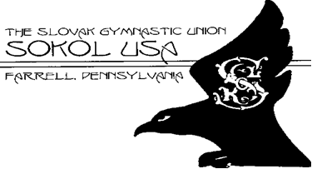
December 2015 Volume 110

110 Years
June 10, 1906 - 2016

We sincerely hope that each and every one of you who are members of Sokol Farrell are reserving the date on your calendar for Sunday afternoon, May 15, 2016 to join us in celebrating the 110th anniversary of the founding of our club. at PARK INN BY RADISSON in West Middlesex, PA.
Our next communication with you will be at the beginning of February when we plan to send you a postal card, again reminding you of the date.
All of our members can expect to receive their personal invitations sometime at the beginning of April, 2016 to attend the banquet “free of charge”. It doesn’t matter if you haven’t been active in our club for a long time. We would like everyone to come, renew acquaintances and have a good time.
Page 2
The program will begin with a hospitality hour at 12:30 PM followed by a program and the dinner. We are looking forward to seeing all of you.

The Christmas Season is Upon Us…
Slovak Christmas Traditions

For those of you who might be familiar with the calendar in most European countries, you know that each day on the calendar is marked with a male or female name. But the names used are different because each country uses names which are typical for that country. So it is also true in Slovakia.
It is also true that in Slovakia the Christian celebration of Christmas is often linked with the pagan feast of the winter solstice. The ancient Slovak forefathers ascribed magic powers to this special time of the year. They believed that the celebration of these rites would serve to protect the crops and cattle from harmful demons, would ensure a good harvest and would bring happiness in family life in the year to come. With the rise of Christianity in Europe this feast was subordinated to the church calendar of Christ being born on December 25. But some of the other Christmas customs which developed were nevertheless taken over from pagan traditions and myths, and even determined the course and character of these celebrations.
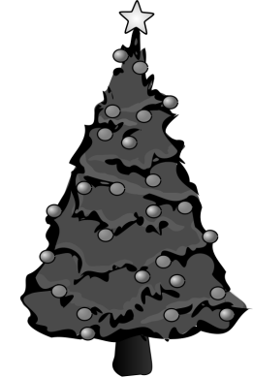
Some of the more famous pagan myths that today have a Christian twist are:
- 11th November, St.Martin's day, was the beginning of the winter solstice;
- 25th November St. Katherine’s day, there followed a winter period of quiet and fasting. It was a time for love magic with all kinds of spells and magic;
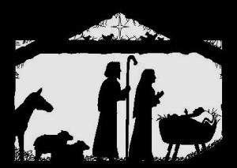
- 30th November, St. Andrew's day, "halushky" (a national dish of dumplings) were cooked, into which unmarried girls put slips of paper of the names of young men;
- 6th December, St. Nicholas day, the traditional day for Slovaks for exchanging gifts;
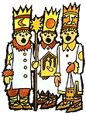
- 13th December, St. Lucia's day, when the powers of darkness were said to do more harm than usual to people's health and property. In the evening women dressed up in fancy dress and ritually chased the evil spirits out of their houses;
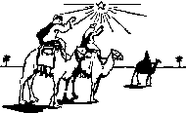
- 24th December (Christmas Eve). The Slovak words for Christmas Eve are literally "bountiful evening" and the bounty of this sacred evening lies in the wide range of festive dishes, of which there had to be twelve different kinds. Even today many Slovak families must have on the Christmas table garlic (to ward off demons), honey, wafers, nuts, cooked peas and beans, dried fruit, pirohy, cabbage soup with mushrooms and "bobalky" - small pieces of dough - with poppy seed and honey. At the beginning of this century, fish has become the traditional meat served during Christmas Eve.
Page 3
- 25th December (Christmas Day). Smoked meats, ham and sausage are served on this day, ending the meatless fast of the day before. Christmas holidays are also very rich in Slovak pastries and baked goods that are prepared over many evenings during the month of December.
- 6th January (Feast of the three kings). The Christmas tree was kept to this day at which time the kids were allowed to finally have the candies and other sweets from the tree.

Page 4

HELP SUPPORT OUR
SOKOL FARRELL GYMNASTICS
BY BRINGING YOUR
FAMILY AND FRIENDS
St. NICHOLAS PARTY
(Mikulášska zabava)
JOHN LAPINSKI ORCHESTRA FOR LISTENING & DANCING

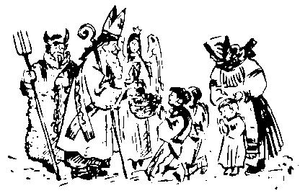
FARRELL SLOVAK HOME
Page 3
800 Spearman Ave.
SATURDAY, DEC. 5, 2015

TRADITIONAL SLOVAK
HOMEMADE FOOD MENU
Appetizer: Choice of Kapusnica (sauerkraut and
kolbasy soup) or Salad, Main Course: Holubky
(stuffed cabbage), Mashed Potatoes, Vegetable,
Home Made European Style Tort and Coffee included.
Food service begins at 5:00 pm.
Carry out service available.
Music is from 6:00 to 9:00 pm.
➔ Free Hot Dogs for the children.⬅
SLOVAK AND ENGLISH
CHRISTMAS SING-A-LONG (words provided).
Page 5

Sokol Farrell Gymnasts
SHOUT OUT
to our Members & Friends...
“Join us in Celebrating
110 Years of Continuous Activity!”

The 110th Anniversary Banquet of
Sokol USA Farrell, PA
Sunday May 15, 2016 at 12:30 PM
Park Inn by Radisson
West Middlesex, PA 16159

Featuring a Performance of the
Slavjane Folk Ensemble of Pittsburgh
Members should look for their personal invitation in the mail!
More information to follow.

Page 6

Sokol Farrell Excels in American Sokol 150th Anniversary Celebration

Our trip started at Pittsburgh International Airport where all 16 of us gathered to board our Boeing 747 bound for Chicago’s O’Hare International. It was a good on time takeoff for a great weekend.
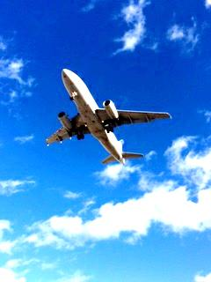
Although it was actually an hour and forty five minute flight, with the change of time zones, we landed just forty five minutes later.
Things happened quickly after that. Get our rental van (the hotel was about 20 miles from the airport), check in to our rooms at the Hilton, pick up our information packets and tickets, have a bite to eat at a pretty good pizza (Italian) restaurant, and leave for the Sports Complex which was another 20 miles in a different direction.
We were given just seven minutes to “rehearse” on the floor. No one was allowed to “rehearse” with their music. We just “walked through” it by counts. We were seventh in a line of nine groups for the rehearsal, so we had time to get accustomed to our surroundings and prepare for the short time we were given on the floor.
Page 7
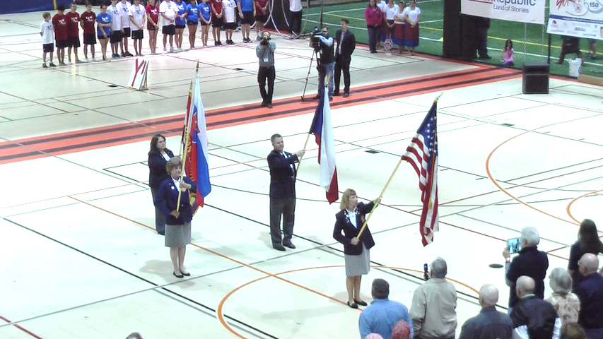

The traditional Sokol fanfare began the show. The flag presentation included the Slovak and Czech flags led by the US flag followed up by the American Sokol flag.

A Sokol group from the Chicago area opened the show.
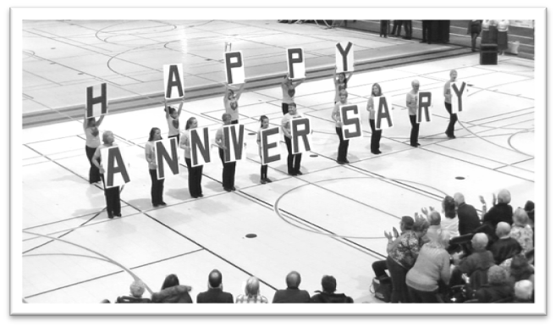
Page 8

Our Sokol Farrell “special number” was second on the program and we were waiting, ready and anxious to perform.
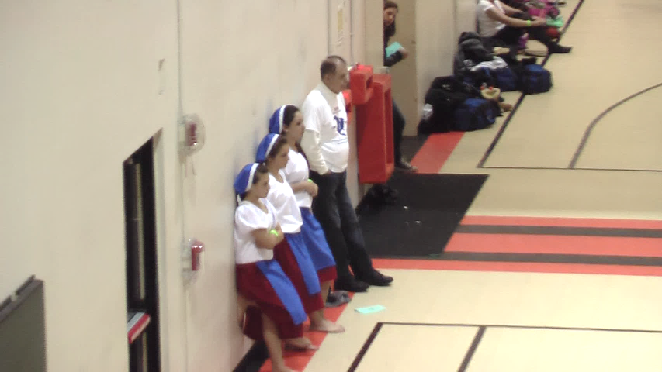
And perform we did!

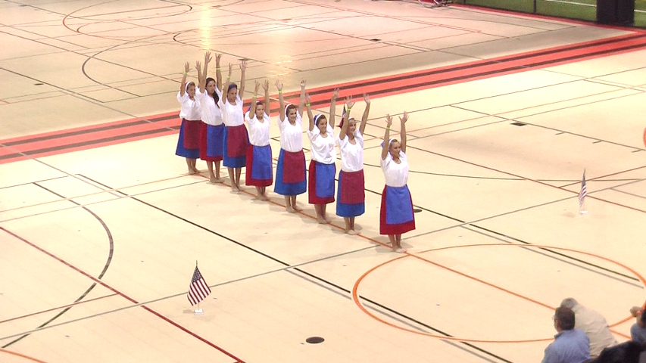
We went from straight line “waves” to different formations to the music of the Slovak “Karička”.
Page 9

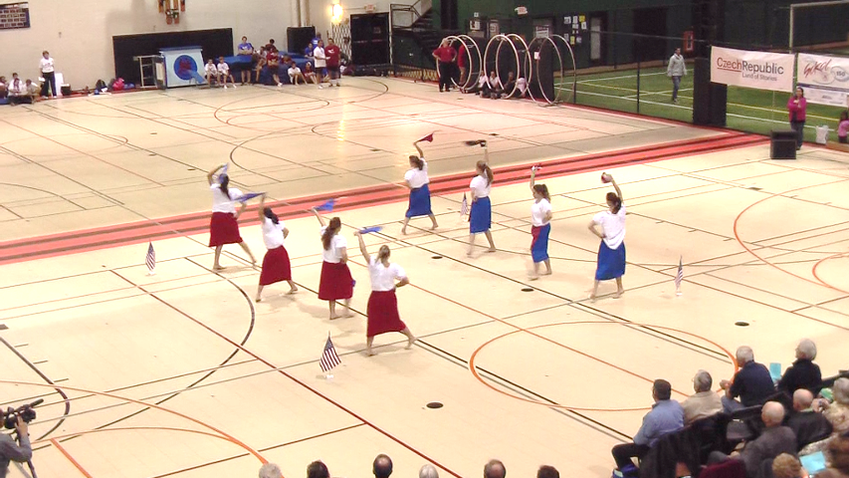
And perform we did! We used our “babuškas as hand apparatus.
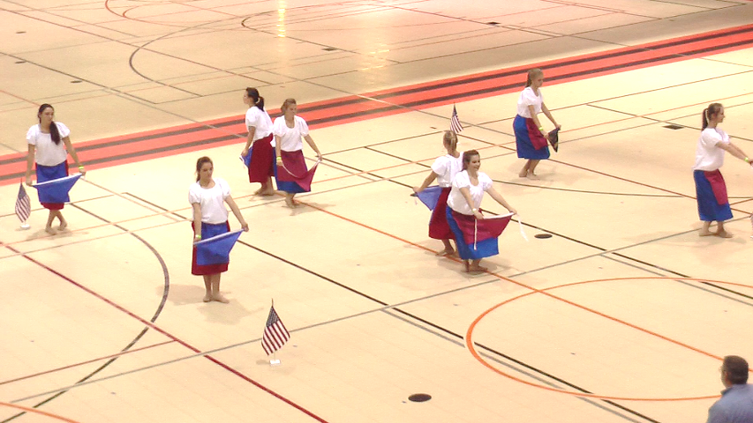
And perform we did! There were dance movements.
Page 10
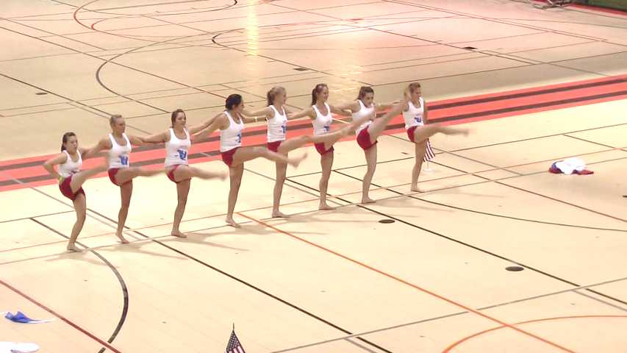

And perform we did! We kicked our legs high!

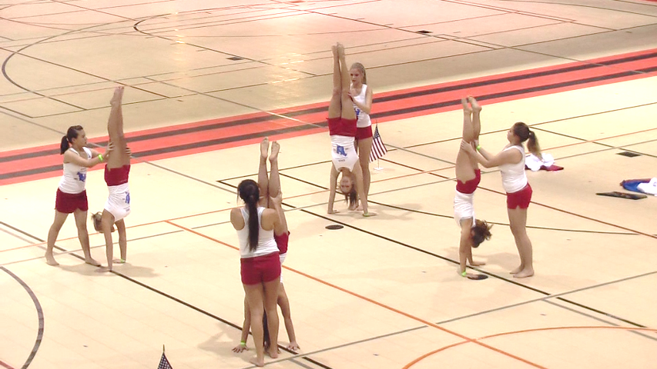

And perform we did! We did handstands!

Page 11
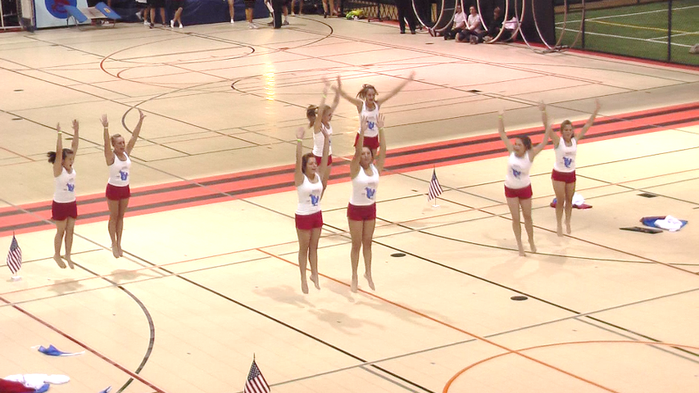

And perform we did! We jumped high in the air!

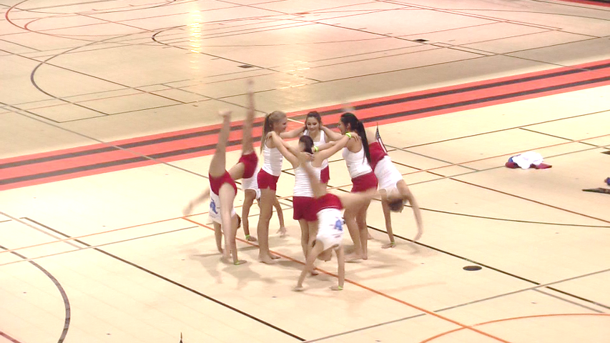

And perform we did! We did cartwheels!
Page 12
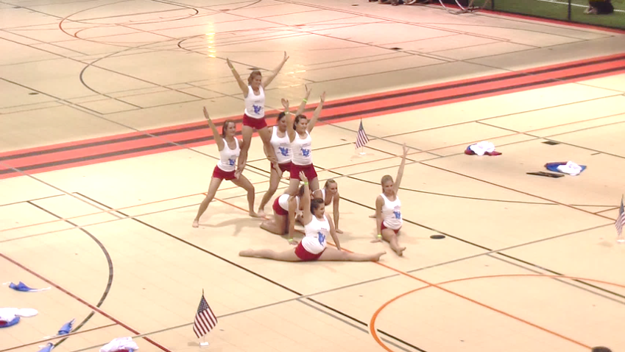
And perform we did... to a perfect Conclusion!
Our long hours of practice paid off in an excellent performance. Some of the comments we heard were... “polished”... “the highlite”... “that is what a Sokol Special Number should be”... “clever”... “it told the story of immigration”... “a good job well done”... “included some surprises”.
But, it wasn’t all work! There was a party planned for Friday evening at the Sports Complex. Saturday morning and afternoon schedules included volleyball and bowling, but our group opted out. Led by Sherry Brandt, Rachel Bender and Sandy Glover, most of our group used the time for sight seeing in Chicago. Val and Jules Hurst-Tamura used the time to visit a relative. But, the parties weren’t over. Saturday evening was a banquet and dancing to a disk jockey.
Sokol USA Farrell officers wish to “Thank” everyone involved in representing our club and the whole Sokol USA organization in a way in which we can be proud of their performance and conduct at this event. Pictured from the left above are: Janel Brandt; Charitee Franks; Rachael Bender, our financial secretary; Sherry Brandt; Alexej Banjak; Roberta Pegg; Ava Glover; Lili Glover and Sandy Glover. Absent from the picture are Tim Brandt, our President; Amanda Michael, our Women’s Director; Stephen Banjak, our Men’s Director; Val and Julianne Hurst-Tamura and Robert Tingler.
Page 13
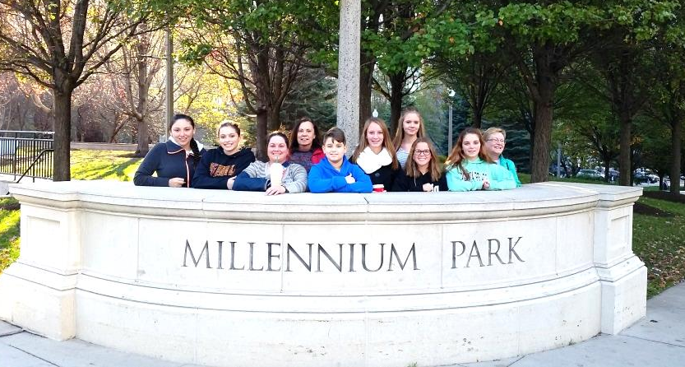
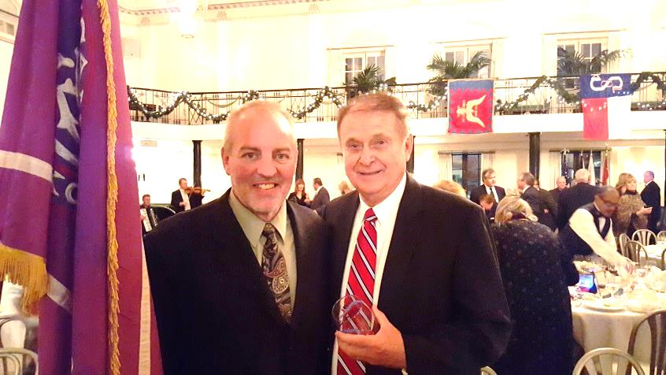
Bros. Tim Brandt and Stephen Banjak at the Gala!
Page 14

