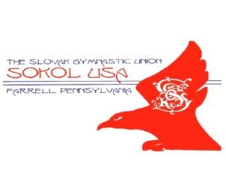
The 12th ANNUAL SOKOL USA FARRELL
4 PERSON OPEN GOLF SCRAMBLE
Shenango Lake Golf Club
June 12, 2021 - 9:00 AM
Benefits Sokol Gymnastics Family & Youth Programs

Donation and Hole Sponsor Information
Sokol USA Farrell, the proud sponsor of this event, is celebrating its 114th consecutive year of fraternal activity. We are a local unit of a worldwide movement founded in the lands of the former Czechoslovakia in the 19th century. We are dedicated to the physical and moral development of our members. The Sokol system of physical education includes movements that originate from gymnastic activities which strive to develop a sound mind and body in every participant, regardless of age, gender or ability. All of the local activities of Sokol USA Farrell are held in the meeting rooms and gymnasium of the Slovak Home, 800 Spearman Ave. in Farrell, PA.

Sokol USA Farrell is a non-profit organization; all contributions to this event are Federal tax deductible; receipts will be provided upon request. We are requesting sponsorships; monetary donations and merchandise for our ELEVENTH consecutive golf scramble. Any help you or your organization can offer to support this event will be greatly appreciated. OUR LAST SCRAMBLE HAD 30TEAMS WITH 125 GOLFERS!

Level of Sponsorship | Donation | Sponsorship Benefits
Corporate Event Sponsor | $300 | Corporate Sponsors listed on Tee shirt; special signage on course; recognition on  Sokol Farrell web-site; recognition in “Sokol Times”, national fraternal newspaper.
Hole Sponsor | $60 | Signage on 2 holes; recognition on Sokol  Farrell web-site; recognition in “Sokol Times”, national fraternal newspaper

- Name/Organization: ____________________________________________________________

- Address: ______________________________________________________________________

- Phone: ( ) _______________

- Level of Sponsorship: ( ) Corporate ( ) Hole Sponsor

Amount Enclosed: ________________________________

Please make checks payable to Sokol USA Farrell and mail along with this form to:
Sandy Glover; 844 Valley View Drive; Brookfield, OH 44403 Phone: Phone: (330) 651-1343

For more information on Sokol Farrell visit our website: http://www.sokolfarrell.org/
AND our Facebook page: https://www.facebook.com/sokolfarrell.org/

