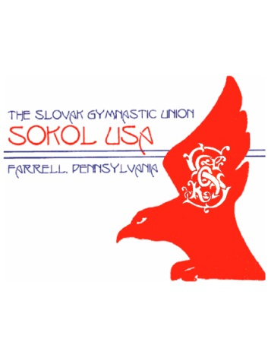j031873614th ANNUAL SOKOL USA FARRELL OPEN

FOUR PERSON GOLF SCRAMBLE

*Benefits Sokol Gymnastics Family & Youth Programs*

SHENANGO LAKE GOLF CLUB 99 Birchwood Dr., Transfer, PA 16154

Saturday June 10, 2023 SHOTGUN START: 9:00 AM

Team Registration Form:

* Registration cost: $70.00 per person

($280.00 per team)

* Registration Fee Includes: Greens fees, cart, t-shirt, door prizes, line prizes, beverages, chicken dinner, and food at the turn!

j0413476

FEATURING:

**Team Prizes** (based on minimum of 25 teams)

**1st Prize:** $800 per team

**2nd Prize:** $400 per team

**3rd Prize:** $200 per team

**4th Prize: $100 per team (random draw)**

* $5,000 Cash for ANY Hole-in-One on #9 hole (Sponsored by Melvin & Dorothy Slezak)
* 50/50 raffle
* $5.00 Skins Game (If there are zero skins, we will pay the least tied hole)
* Bet Hole
* Prize Boards ($25.00 minimum value)

Entries Accepted on “First Come” basis. ***Limit of 30 teams.***

|  |  |  |  |  |
| --- | --- | --- | --- | --- |
|  | **Team Captain (required):** | **T-shirt size** | **Phone (required)** | **Check if Sokol member 🗹** |
| 1. |  |  |  |  |
|  | **Player’s Name** | **T-shirt size** | **Phone** |  |
| 2. |  |  |  |  |
| 3. |  |  |  |  |
| 4. |  |  |  |  |

*All Sokol members in good standing may deduct $5.00/individual from registration fee.*

Please make checks payable to SOKOL USA FARRELL and mail along with this form to:

Sandy Glover; 844 Valley View Drive; Brookfield, OH 44403. **Phone: (330) 651-1343**

Questions… call Scramble Chairman, Tim Brandt: **(724) 866- 8553**